**Maged Ibrahim Eid**

**Maged’s Store (Website)**

**(Website for selling Tech Devices)**

**Table of contents:**

1. Introduction (Background)

2. Situation Analysis (SWOT)

3. Segmentation, targeting and positioning

4.Objectives of E-Marketing

5. Statistics

6. Business Model (B2C & B2B)

7. Owned media (Website using Webbly E-commerce website builder)

8. Transactional ecommerce Site

9. E-marketing strategies

10. The Offer: Product Strategies

11.The Value: Pricing Strategies

12. Distribution Strategies

13 Marketing Communication Strategies

14. Relationship Management Strategies

15.Conclusion and Recommendations.

**Introduction (Background):**

As MIS major I want to get a good position in one of the big Information Technology (IT) companies but at first I want to make my own company and use my technological knowledge in IT field to make my small website startup which is going to offer electronic devices such as (mobiles,laptops,gaming consoles,etc) as I am going to be a middle man between the customer and any online store such as amazon and deliver the product that customer want into his doorstep without any complications and offer few devices at first to sell directly to customers through website too at the beginning of the website too decrease and not spend too much money at the beginning, The vision is to be one of the big names in the IT selling sector not only in Egypt but in the whole world so to achieve this goal I need to learn more and gain experience for a while, so I need to study the Egyptian market as I can to know how the market operate and try to offer good deals for customers in Egypt to buy new devices safe in Egypt.

**Situation Analysis for me & my online store (SWOT):**

|  |  |
| --- | --- |
| Strength:   * Offer devices from unfamiliar brands in Egypt with high quality and good prices * Curious to know about new technology and new trends. * Realistic person and pragmatic to the market fluctuations * Offer good online customer service after selling | Weakness:   * A lot of huge competitors * High Tax prices for devices in Egypt * Corona situation affect the world. |
| Opportunities:   * A lot of online and free sources to learn and achieve more. * Offer good and affordable prices because its an online store * Huge and promising market for IT sector in the whole world. * Rising job vacancies for IT Sector. | Threats:   * Corona virus now affect a lot of things so we don’t know what is going to happen in the IT Sector. * Rivalry among companies to enter the IT selling Sector. |

**Segmentation, targeting and positioning:**

**Segmentation:**

* Interests: anyone interested in buying electronic devices
* Age: any age
* Lifestyle: medium income with a niche section for high range prices
* Gender: both

**Targeting:**

Electronic devices & Gadgets for medium income people with good quality.

**Positioning:**

Medium range prices for the devices such as (mobiles, laptops, gaming consoles, etc.) to be affordable in the Egyptian market.

**Objectives of E-Marketing Plan:**

* **Increase revenue:** the primary goal of any marketing strategy is ultimately to increase revenue, and Internet marketing is no exception. Thankfully, the Internet provides plenty of opportunities for every business to improve their bottom line.
* **Improve local SEO:** many small businesses, as well as companies focused on increasing sales in specific geographic region, focus much of their marketing efforts on improving their local SEO. This means optimizing various elements on their sites in order to attract local customers how are seeking buying electronic devices.
* **Build a brand:** internet marketing objectives often include building a brand. This means not only establishing your logo and company name in the minds of consumers, but also what your company stands for.
* **Manage online reputation:** in an age when anyone with a computer or smartphone can post their opinions about companies, products, and services for the whole world to see, it’s important for businesses to maintain a solid online reputation.

**Statistics: (Egypt also rise in sales but not at the same percentage.)**

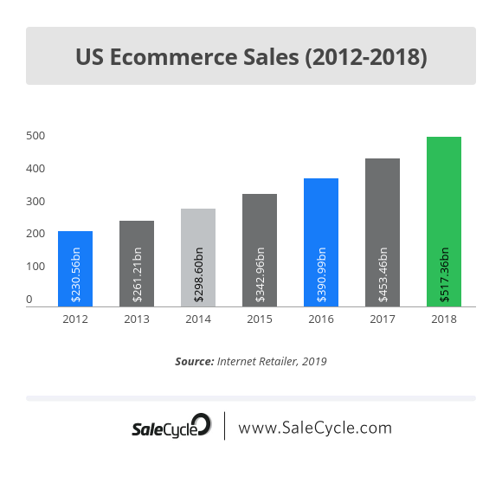

Importance of Online Marketing:

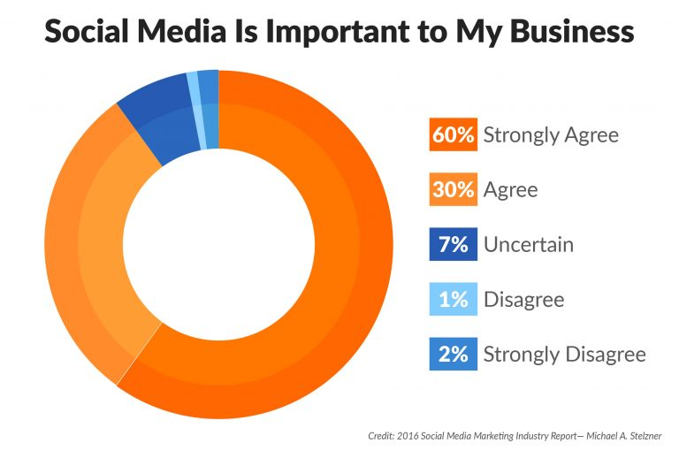

**Business Model (B2C & B2B):**

**Why B2C ?:**

The goal of B2C marketing is to sell products and services to its target consumers. In order to reach that goal, B2C digital marketers have to speak to their audience in a way that establishes trust and brand authority.

**Why B2B ?:**

Venturing to a Business – to – Business marketing strategy allows companies and business owners to expand and widen reach of audience. Maximizing the use what the internet can offer, B2B commerce can reach all levels of market audience whenever and wherever part of the world.

**Owned media (Website using Weebly):**

**I am going to make my online e-commerce store using this online website (E-commerce builder).**

Weebly's free website builder makes it easy to create a website, blog, or **online store**. Find customizable templates, domains, and easy-to-use tools for any type of websites.

**Screenshots:** 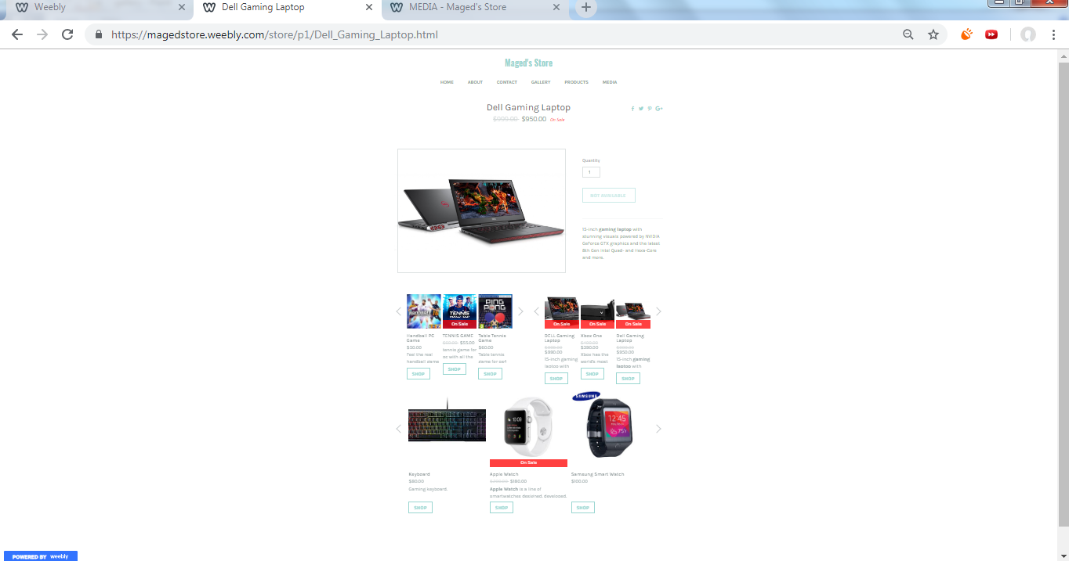

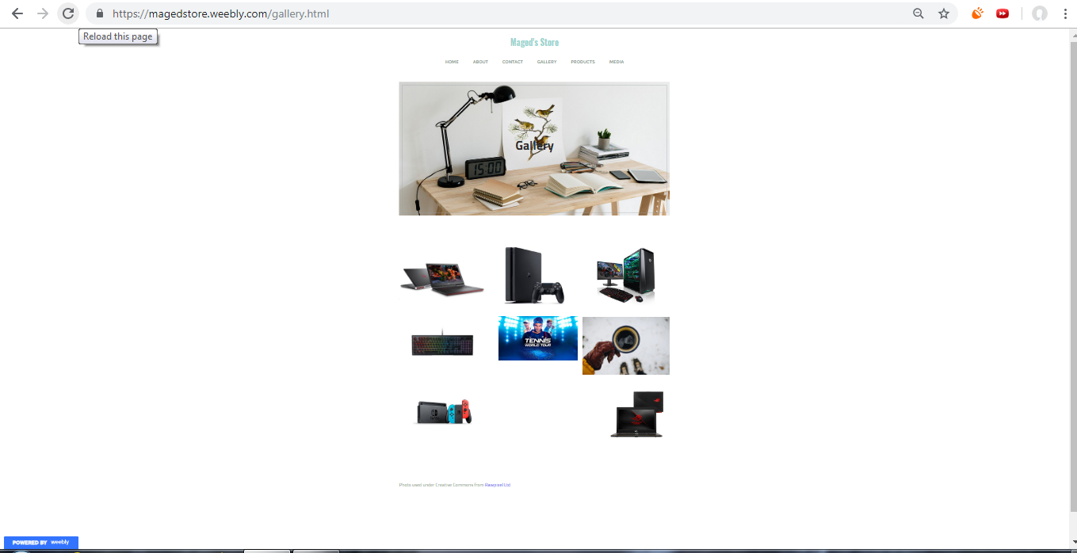

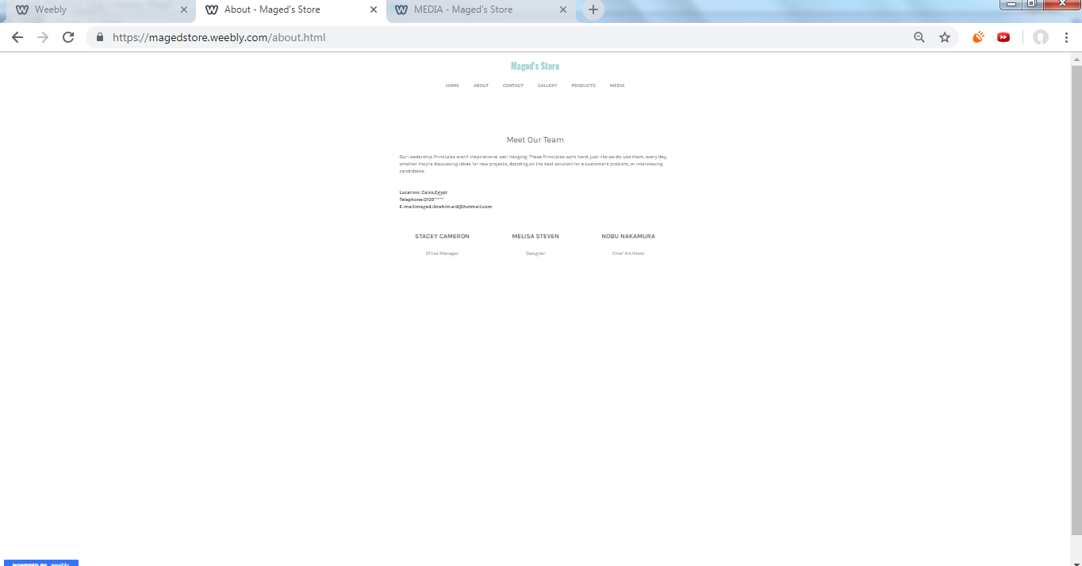

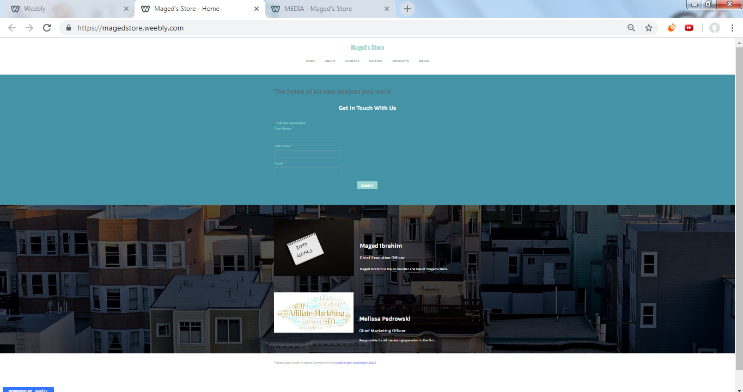

**Link:**magedstore.weebly.com

**Transactional ecommerce Site:**

with a single website, anything and everything that a transaction needs, can be executed online and selling through internet is the most effective way nowadays.

**E-marketing strategies I am going to use in the future:**

* **Search engine optimization (SEO):** is the process of increasing the quality and quantity of website traffic by increasing the visibility of a website or a web page to users of a web search engine. SEO refers to the improvement of unpaid results and excludes direct traffic and the purchase of paid placement.

**Using:** Google Search Console

* **E-marketing analytics:** is the practice of measuring, managing and analyzing marketing performance to maximize its effectiveness and optimize return on investment (ROI).

**Using:** Google Analytics & Mixpanel.

* **Content marketing:** is a strategic marketing approach focused on creating and distributing valuable, so focusing in using Facebook as it’s the largest social media in Egypt to attract new customers.
* **Social Media Marketing:** Focusing in using Facebook as it’s the largest social media in Egypt.

SO:

1. Set meaningful social marketing goals on Dailey reach for specific areas.
2. Research your target audience.
3. Establish your most important metrics.
4. Analyze your competition with other online retails.
5. Create and curate engaging content.

**The Offer: Product Strategies:**

Creating a successful product requires more than a great idea. So I need to plan every step of the process. It's crucial that you differentiate yourself from the competition and give customers a reason to choose your brand. That's where a well-thought-out product strategy can help so the product that I am going to offer to my customers should be:

* Affordable
* High quality
* Unique brands that’s not familiar in the Egyptian market
* Always adding new devices and products
* Offers on devices with good prices for customers and small revenue margin for me.

**The Value: Pricing Strategies:**

Value-based pricing: according to the customers preference which is going to range from medium prices and a small niche for high prices so primarily based on a consumer's perceived value of the product or service in question. Value pricing is customer-focused pricing, meaning companies base their pricing on how much the customer believes a product is worth.

**Distribution Strategies:**

is a strategy or a plan to make a product or a service available to the target customers through its supply chain so:

* **Location of business:** Starting first from my home and offering products in my website then buy this product from Amazon or any online store which is provide the product then deliver this product to the customer doorstep without any complications that’s may face the customer
* **Warehousing:** small one with few devices at first and I am not going to need any warehouse for high prices devices because I am going to be a middle man between any online store and the customer
* **Transportation and logistics:** Using companies as FedEx to deliver the products to the customers.

**Marketing Communication Strategies:**

* **Product Launch:** Generating media and customer interest in a product launch.
* **Promotion:** Trying always to provide best deals to the customers.
* **Customer Service:** Provide 24/7 online chat to provide any information or any questions from customers.
* **Advertising:** Using online social media platform such as (Facebook, Twitter) and focusing on Facebook because it’s the largest platform in Egypt.

**Relationship Management Strategies:** To gain customers trust I am going to set these strategies always with dealing with customers:

* **Using CRM System:** As these system provide accurate information using Customer relationship management is an approach to managing a company's interaction with current and potential customers. It uses data analysis about customers' history with a company to improve business relationships with customers, specifically focusing on customer retention and ultimately driving sales growth and its going to be very helpful to know customer buying pattern

**Using: Oracle CRM**

* **Respect the Client’s Time in Delivering:** Time is the most precious and finite resource you and your clients have. If you want to build healthier relationships, you have to respect their time.
* **Build Credibility Over Time**: It takes time to build credibility, but offering good prices and good customer service is going to build the trust.

**Conclusion and Recommendations:**

At the end of this project I learned how to make a good e-commerce website along with solid e-marketing plan to boost the site and make the site reach more people who are interesting in Technology and electronic devices so I recommend this site to any one seeking a good experience to buy any device that is not available in Egypt and take a look at the unique devices I provide that doesn’t have a huge familiarity in the Egyptian market.